Chapter 3: Methodology

3.1. Research Framework and Scenario Design
This study employs a quantitative simulation programmed in Python to evaluate the short-term cost-effectiveness of maintenance strategies for offshore wind farms operating under severe metocean constraints. The simulation loop operates on 3-hours temporal resolution to accurately track evolving weather windows.
The core architecture builds upon the framework established by Frederiksen et al. (2024), which evaluated the economic viability of predictive maintenance using an optimal routing model. However, their reference model inherently simplified offshore logistics by assuming continuous, perfect weather conditions (a flat sea state). In reality, maintenance operators require strict meteorological windows to safely deploy technicians. To address this limitation and reflect true offshore operations, this research introduces a dynamic "weather gate" framework.
To comprehensively assess the impact of these metocean constraints, the simulation evaluates a matrix of four distinct scenarios, combining two maintenance strategies with two vessel types:
- Preventive Maintenance executed by a Crew Transfer Vessel (CTV).
- Predictive Maintenance executed by a CTV.
- Preventive Maintenance executed by a Service Operation Vessel (SOV).
- Predictive Maintenance executed by a SOV.

3.2. Data Acquisition and Baseline Parameters

3.2.1. Wind Farm Location and Foundational Dataset
The spatial configuration of the hypothetical wind farm is directly derived from the dataset provided in Frederiksen et al.'s (2024) study on cost-effectiveness. As illustrated in Figure 3.1, the simulation considers a subset of 20 Wind Turbines (WTs) distributed across a 20 km by 15 km area, with specific Cartesian coordinates (X, Y) assigned to each asset to calculate Euclidean routing distances.
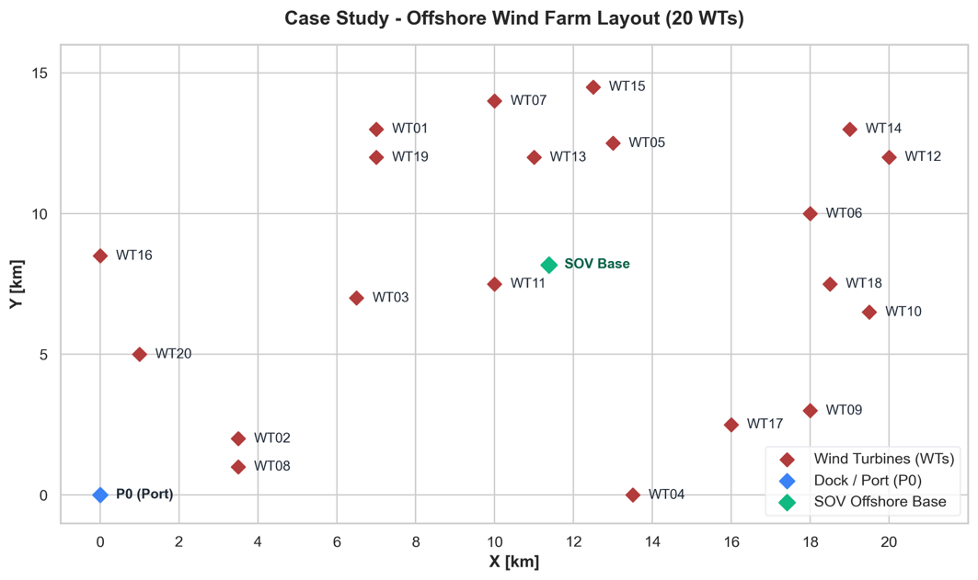
Furthermore, to accurately simulate the predictive maintenance scenario, the daily downtime probabilities ($Pr_{Di}$) for each specific turbine over the 7-day campaign were extracted from Frederiksen et al.'s complementary research on integrated maintenance planning as shown in the Figure 3.2. Utilizing this peer-reviewed baseline dataset ensures the foundational inputs of the simulation remain academically rigorous.
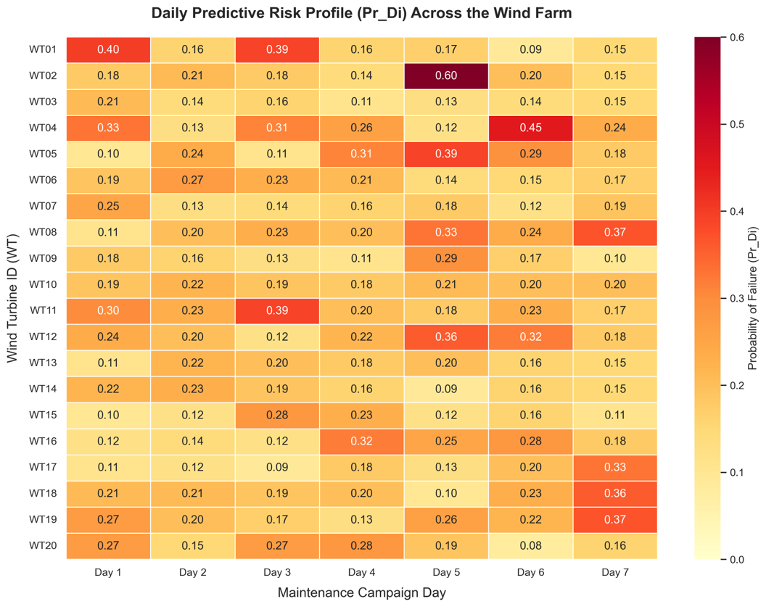
To provide a realistic metocean context for this layout, the farm was situated off the coast of Aberdeen, in close proximity to the actual European Offshore Wind Deployment Centre (EOWDC). The chosen barycenter coordinates are Latitude: 57.2139, Longitude: -1.9223. Historical hourly Significant Wave Height (H_s) data for this location was extracted from the Copernicus Marine Service (NetCDF files) using a custom Python script (Hs.py) with a 3-hour temporal step.
Crucially, a sensitivity analysis was conducted to evaluate the spatial resolution of the metocean data by extracting H_s values not only for the farm's center but also for its four corners. As shown in Figure 3.3, a distinct East-West gradient was observed during low-pressure passages, where the Western edge occasionally dropped below the vessel operational limit while the Eastern edge remained inaccessible. While a highly complex routing algorithm could theoretically exploit these micro-windows, this study maintains the assumption of a single reference point at the farm's center to prevent an explosion of algorithmic complexity, which would shift the project into a dynamic spatio-temporal routing problem beyond the intended scope.

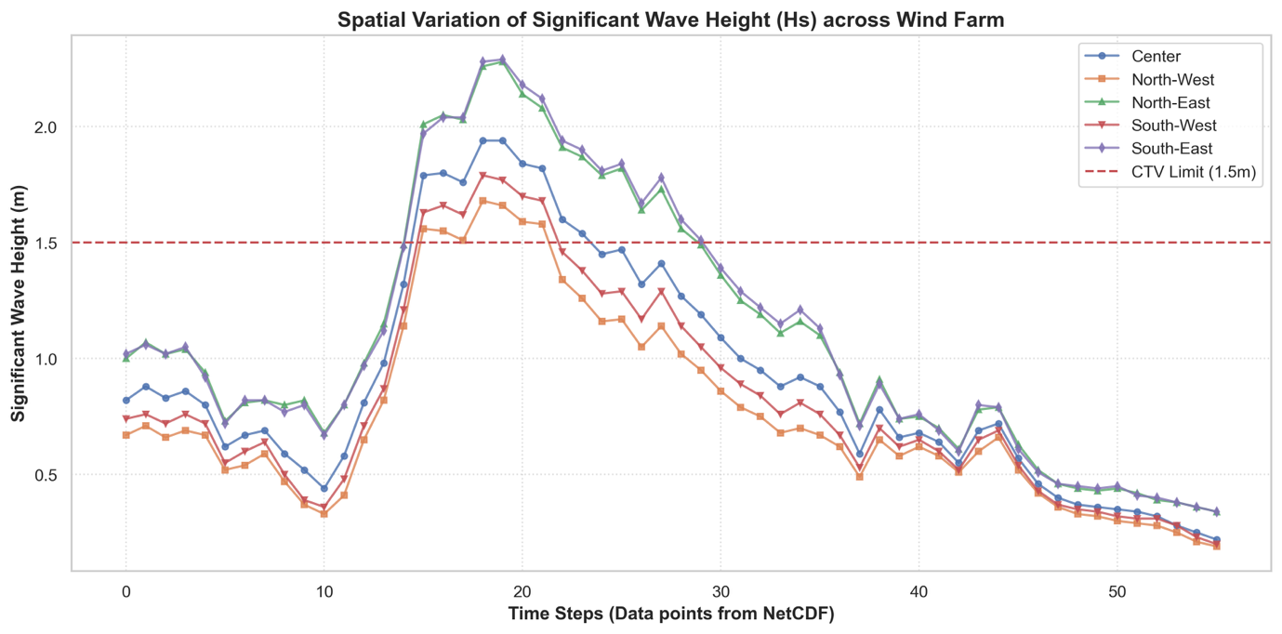3.2.2. Vessel Specifications and Logistical Constraints
The logistical model contrasts two primary offshore access vessels, parameterized using current industry standards and primary data gathered from Fraser Dobbie (Chief Financial Officer at North Star) during the Global Offshore Wind 2026 conference in Manchester.
- CTV: While theoretical specifications often suggest a 1.5m wave limit, industry practice dictates a stricter operational limit of 1.3m $H_s$ to ensure safe technician transfer (Dobbie, 2026). The CTV operates with a transit speed ($V_s$) of 8.0 m/s, a fixed daily charter cost ($FCV$) of €3,400, an active hourly fuel cost ($COF$) of €400, and a daily crew cost ($COL$) of €1,440. CTVs consume fuel primarily during active daily shifts (transit and idling at the turbine).
- SOV: Designed for harsher environments, the SOV can theoretically operate in up to 3.5m $H_s$. However, operations are practically restricted by wind speeds exceeding 40 knots, which prevents safe technician transfer. The SOV operates with a transit speed of 6.2 m/s, a daily $FCV$ of €35,000, and a $COL$ of €4,500. Regarding fuel, the SOV consumes approximately 3.5 tonnes of Marine Gas Oil (MGO) per day. Based on the Rotterdam MGO market price (June 2026) of $875/t (€767/t), the raw fuel cost is approximately €2,686 per day. To account for port bunkering and logistical fees, this is rounded to a fixed rate of €3,000 per day. Unlike CTVs, SOVs inherently consume fuel continuously over a 24-hour cycle to maintain offshore dynamic positioning and hotel loads.

3.2.3. Economic and Wind Farm Baselines
Aligning with the parameters from Frederiksen et al., the WTs have a nominal power of 3.6 MW. Revenue losses are calculated using a wind efficiency factor ($W_{factor}$) of 0.9 and an assumed energy market price ($Price_{MWh}$) of €168/MWh. The mean duration of an unprevented downtime event ($h_{downtime}$) is 3.5 hours. Standard maintenance tasks require a service time ($TS$) of 120 minutes and a mobilization time ($TI$) of 15 minutes per turbine, constrained within a maximum 12-hour working day limit ($H$).

3.3. Simulation Architecture and Algorithmic Logic

3.3.1. Simulation Loop and Rolling Horizon Planning
The simulation operates on a Rolling Horizon Planning logic. Rather than generating a static, rigid maintenance queue at the beginning of a campaign, the algorithm performs a global re-prioritization at the start of every operational day. This ensures that the dispatch logic dynamically adapts to weather-induced delays and evolving turbine risks.
This programming logic deliberately diverges from the constraint optimization approach utilized by Frederiksen et al. While literature often relies on commercial Mixed-Integer Linear Programming (MILP) solvers like IBM ILOG CPLEX for maintenance scheduling, the combinatorial explosion associated with integrating severe hourly metocean constraints rendered free-tier solver limits (typically capped at 1,000 constraints) unviable. Therefore, a custom Python-based heuristic combining daily risk-prioritization with an exact combinatorial routing algorithm was developed, ensuring computational independence and total adaptability to dynamic weather windows.

3.3.2. Target Selection
Target prioritization varies fundamentally between the two maintenance strategies:
- Preventive Strategy: Turbines are prioritized iteratively based on direct geographic proximity (Euclidean distance) to either the logistical base or the most recently serviced turbine.
- Predictive Strategy: Turbines are ranked strictly by their Predictive Risk Score ($Pr_{Di}$), prioritizing assets with the highest probability of imminent failure. Each day, a subgroup of maximum 6 turbines is selected to form the primary target list. Crucially, because these high-risk assets are geographically scattered across the wind farm, the logistics cannot simply default to visiting the "nearest" turbine. Instead, the simulation computes a globally optimized route.

3.3.3. Routing Algorithm and Time Window Constraints
To minimize transit time and fuel consumption when servicing the scattered targets, the daily vessel route is optimized using a custom Traveling Salesperson Problem (TSP) solver. For any given subgroup, the algorithm utilizes combinatorial logic (itertools.permutations in Python) to generate all possible visiting orders.
For each permutation, the solver calculates the cumulative Euclidean distance ($d$), starting from the base coordinates, travelling through each turbine, and returning to the base:
$$d = \sqrt{(X_2 - X_1)^2 + (Y_2 - Y_1)^2}$$
The sequence yielding the absolute minimum total distance ($D_{total}$) is recorded as the optimal route. The total duration of the daily mission ($Shift\_Time$, in hours) for this $N$-turbine route is computed as the sum of transit time and operational time:
$$Shift\_Time = \left( \frac{D_{total}}{V_s \times 3.6} \right) + \frac{N \times (TS + 2 \times TI)}{60}$$
To enforce the 12-hour operational limit ($H$), a "Fallback Queue" mechanism is implemented. If the optimized $Shift\_Time$ exceeds $H$, the algorithm iteratively removes the furthest turbine from the day's subgroup and recalculates the TSP route until a compliant schedule is achieved.

3.4. The Weather Gate: Metocean Operational Constraints
A defining, novel feature of this methodology is the integration of high-resolution weather constraints. Once a compliant route is generated, a dynamic weather check evaluates the $H_s$ along the required continuous working hours. Since the metocean data operates on a 3-hour temporal resolution, the required number of clear weather blocks is calculated as:
$$Blocks = \lceil \frac{Shift\_Time}{3} \rceil$$
If the maximum significant wave height during these required blocks exceeds the vessel's specific operational limit ($\max(H_s) > Vessel\_Limit$), an Abort & Push protocol is triggered. The mission for that specific group size is aborted, and the algorithm attempts to route a smaller subgroup. If even a single turbine cannot be safely accessed, a "No-Go" day is declared, all targets are pushed to the following day, and downtime penalties continue to accrue.

3.5. Financial and Campaign Performance Evaluation
The core objective is to financially evaluate the impact of the operational logistics. The performance of the campaign is measured by the operational profit equation proposed by Frederiksen et al. (2024):
$$P_T = Rev_T - CoD_T - CS_T - CPS_T$$
In their model, the total net profit ($P_T$) is defined as the actual revenue generated minus the logistical costs ($CS_T$) and the AI implementation costs ($CPS_T$). The actual revenue itself is calculated by subtracting the Cost of Downtime ($CoD_T$) from the potential maximum revenue ($Rev_T$).

3.5.1. Maximum Revenue and Cost of Downtime ($Rev_T$ & $CoD_T$)
The Maximum Potential Revenue ($Rev_T$) represents the theoretical income generated if all turbines operated flawlessly. For a single turbine, the hourly revenue potential ($Rev_{hour}$) is:
$$Rev_{hour} = MW \times Price_{MWh} \times W_{factor} \times Discount$$
To calculate the penalties subtracted from this revenue under a predictive framework, the expected number of failure events per turbine ($E_{expected}$) is determined based on the AI's predictive accuracy:
$$E_{expected} = (Pr_D \times MSTP) + ((1 - Pr_D) \times MSFN)$$
In this formulation, derived from Frederiksen's efficiency framework, reliability is quantified using two critical membership scores. The Membership Score True Positive ($MSTP$) represents the probability that the AI correctly identifies a degrading turbine. Conversely, the Membership Score False Negative ($MSFN$) signifies the critical error rate where the AI fails to predict an imminent breakdown. $Pr_D$ represents the inherent baseline probability of degradation (as extracted from the dataset over the 7-day campaign).
Consequently, $E_{expected}$ encapsulates both the failures the AI successfully anticipates and the unanticipated failures resulting from the $MSFN$ gap. A high $MSFN$ inevitably leads to unexpected downtime.
For every expected failure that is not prevented—either due to low risk prioritization or weather-induced "No-Go" days—the Cost of Downtime ($CoD_T$) actively accumulates:
$$CoD_T = \sum_{days} \left( \max(0, E_{expected} - E_{prevented}) \times h_{downtime} \times Rev_{hour} \right)$$

